**Launch an Amazon EC2 Instance**

1.

Enter the search bar and search for EC2.

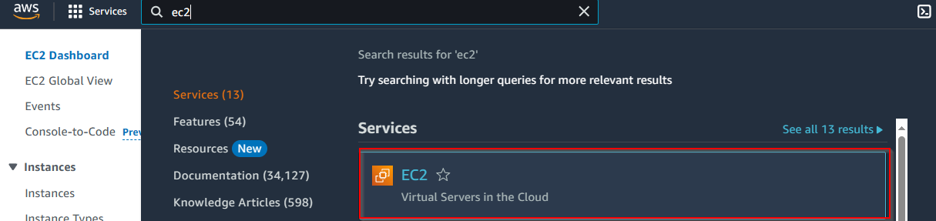

2.

In the EC2 Dashboard, Select “Launch Instance”

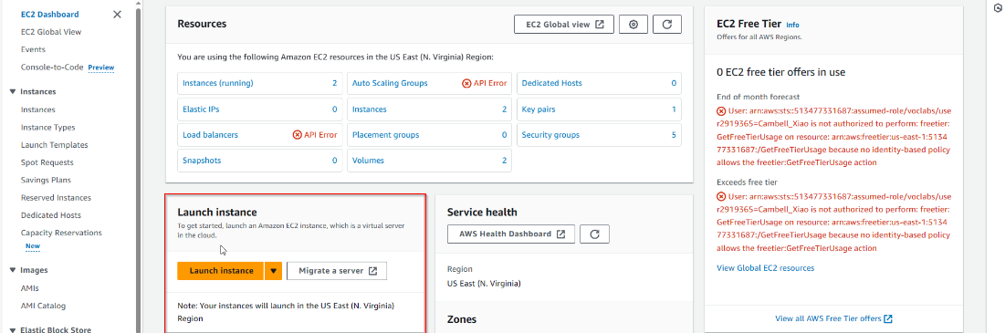

3.

Give a name to the Web Server

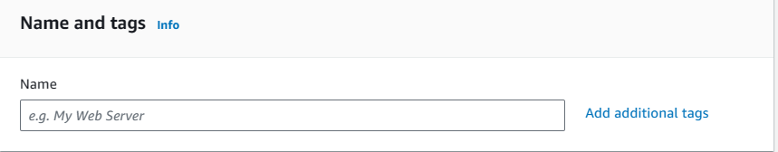

4.

Select an Amazon Machine Image. This is what operating system your EC2 instance will run on.

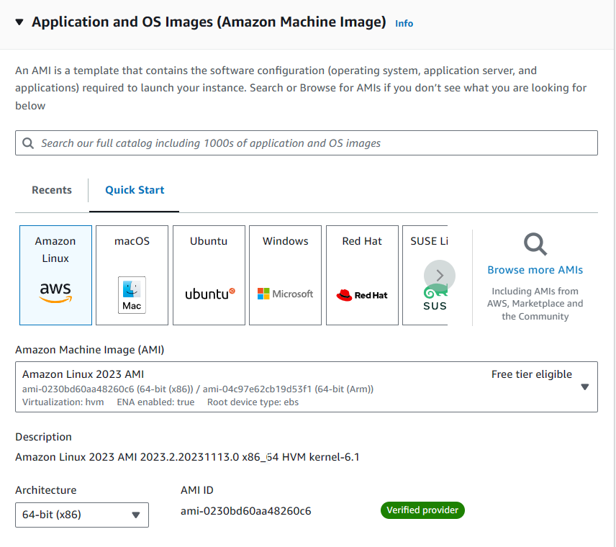

5.

Select an Instance Type for your EC2 Instance. This will determine CPU, Memory, RAM, storage, and networking.

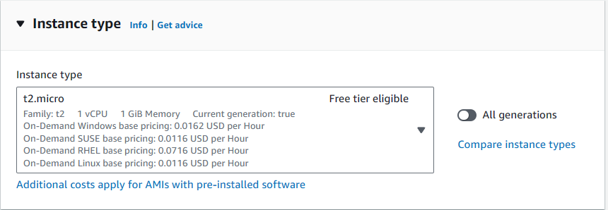

6.

Select a Key Pair. For this lab we will use Vockey.

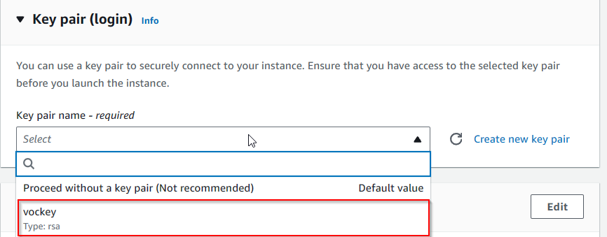

7.

Enter Network Settings and select which VPC you want to bind this EC2 instance to, a subnet, and a firewall security group, and which security group you want to add to this instance. Delete Inbound Security Group rules as well if you want to configure it later or don’t need it.

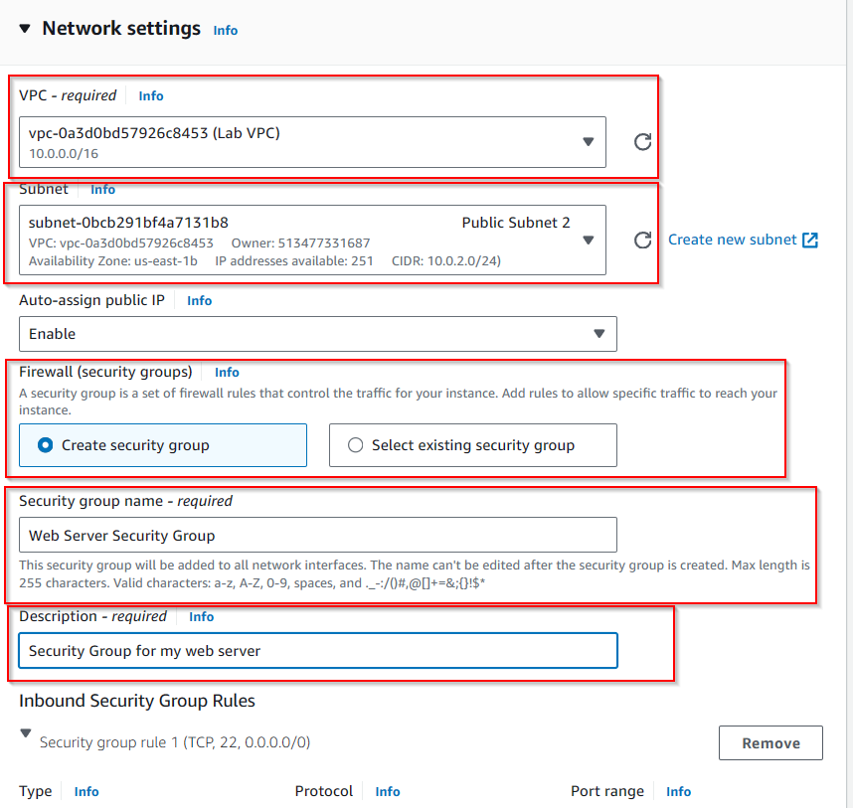

8.

Configure storage settings. For this lab we will use the default.

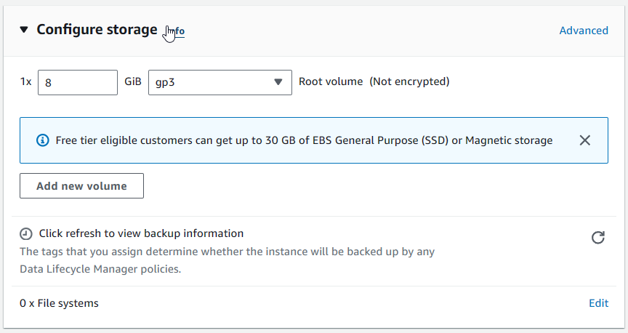

9.

Enter “Advanced Settings” and enable termination protection so your instance cannot be removed from the API or CLI.

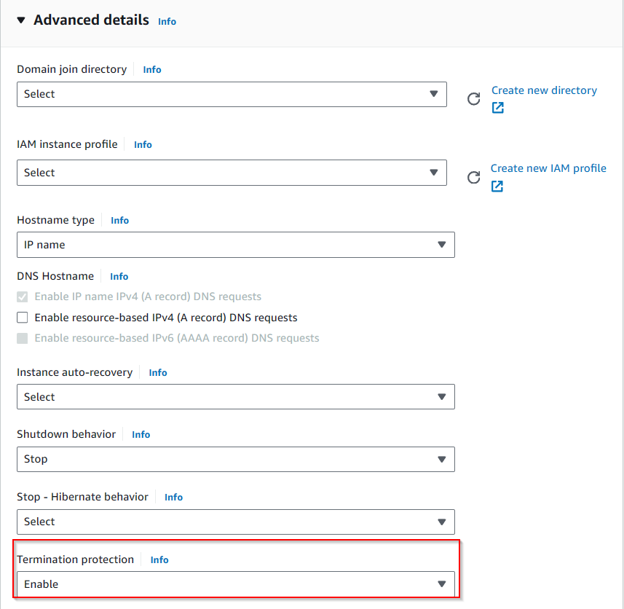

10.

Enter code into User Data if applicable. The code used in this lab will install the Apache web server, configure the server to start on boot, runs the web server as soon as it finishes installing, and creates a simple web page for the server. Then Launch the instance.

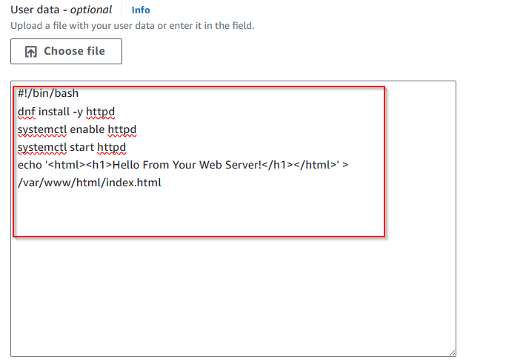

11.

Launch the instance.

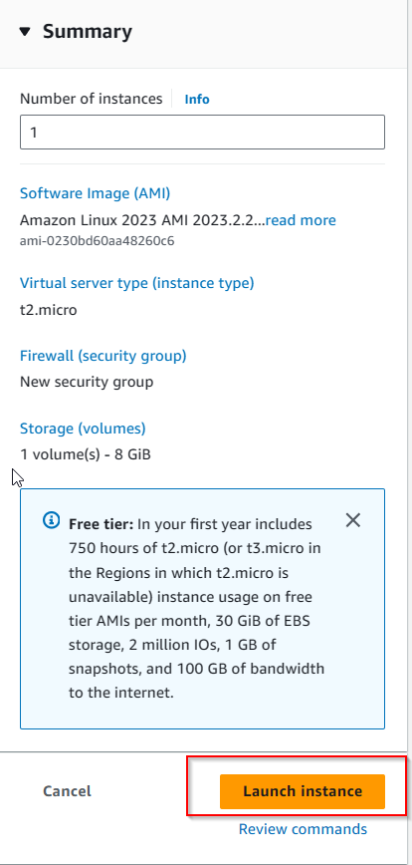

**Monitor Your Instance**

11.

In the Instances Tab, select “web server” and notice that it has details about instance type, security settings, and network settings.

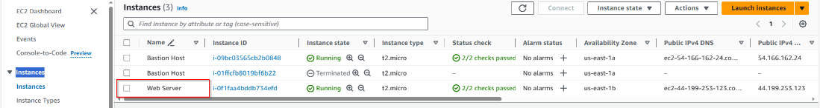

12.

The “Status checks” tab is used to determine if AWS has detected any problems that may interfere with the running of this instance.

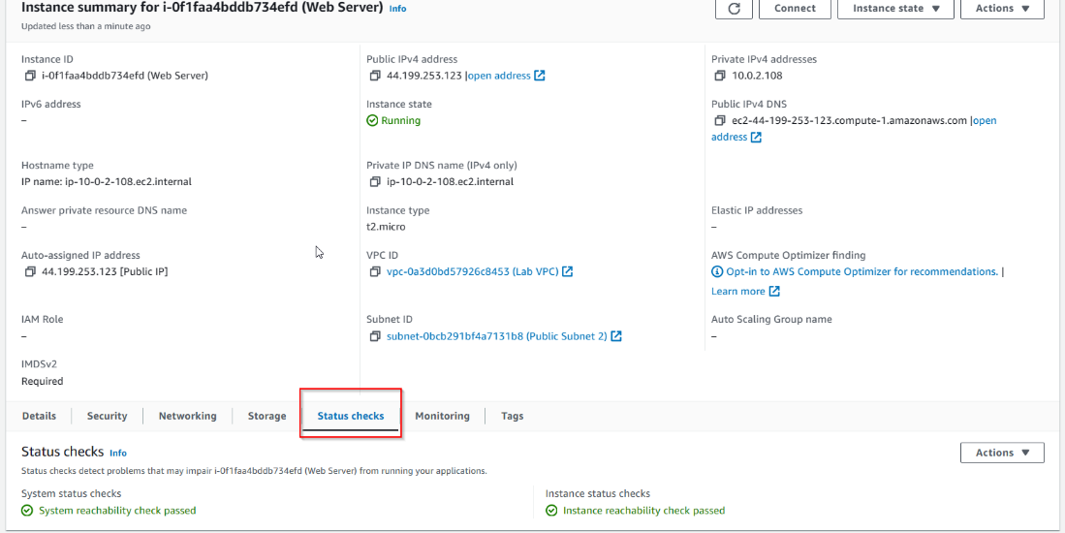

13.

In the Instance menu, select “Actions”, “Monitor and Troubleshoot”, and “Get System Log” to access Cloudwatch Logs on your instance.

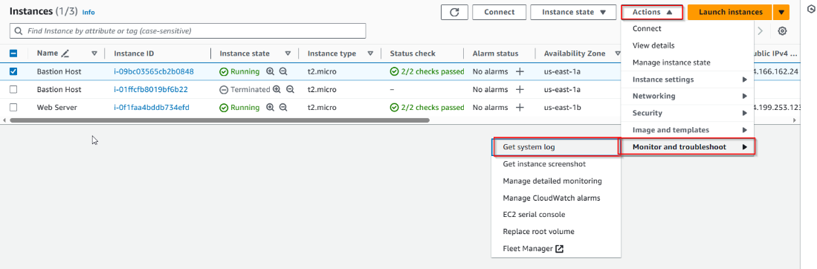

14. In the instance menu, select “Actions”, “Monitor and Troubleshoot”, and “Get Instance Screenshot” to access a preview of the EC2 instance if you were to connect to it.

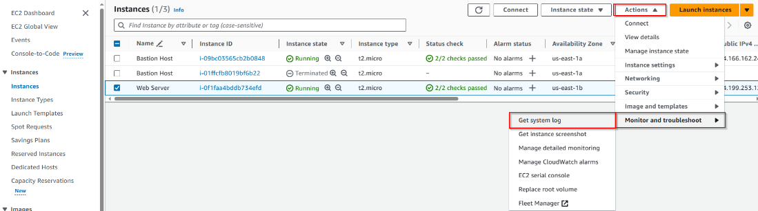

**Update Security Groups and Access Web Server**

15.

In the Details tab of the instance summary, copy the IPv4 public ip address. However, this link wont work yet since your security group is blocking inbound port 80 traffic.

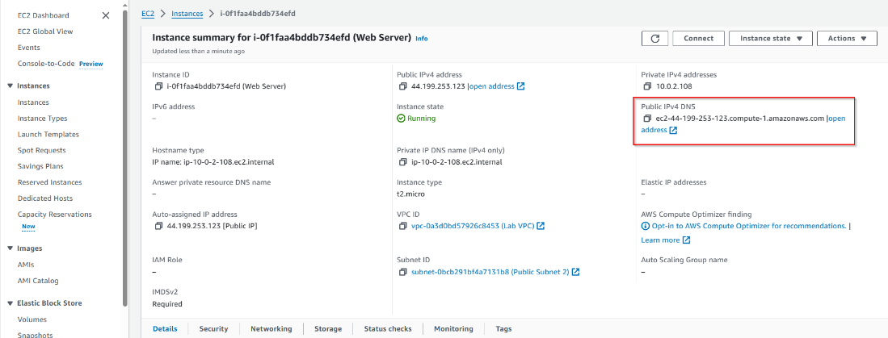

16.

Select “Security groups” and select “Web Server”

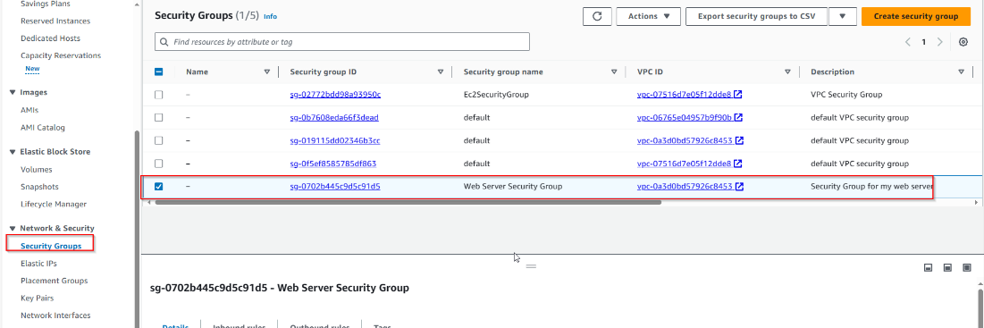

17.

Select “Inbound Rules” and Edit inbound rules.

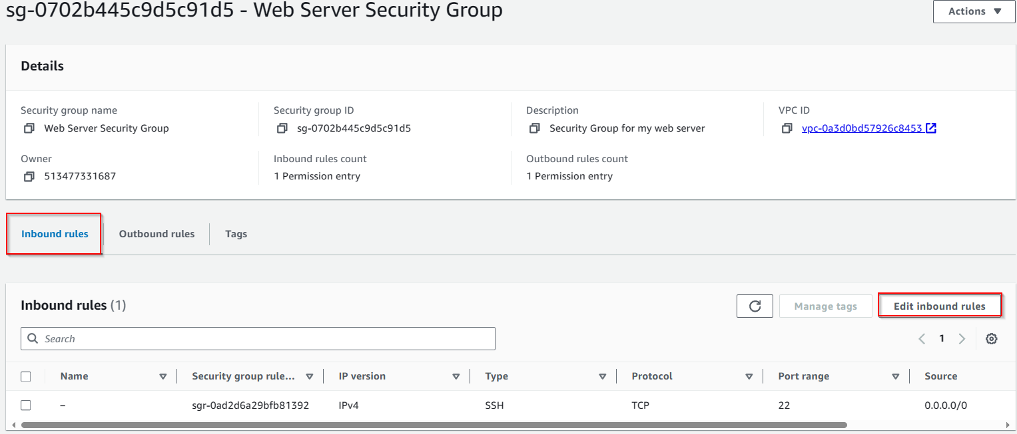

18.

Select “Add Rule” and create a new rule that allows HTTP access from anywhere IPv4. Then Save the config.

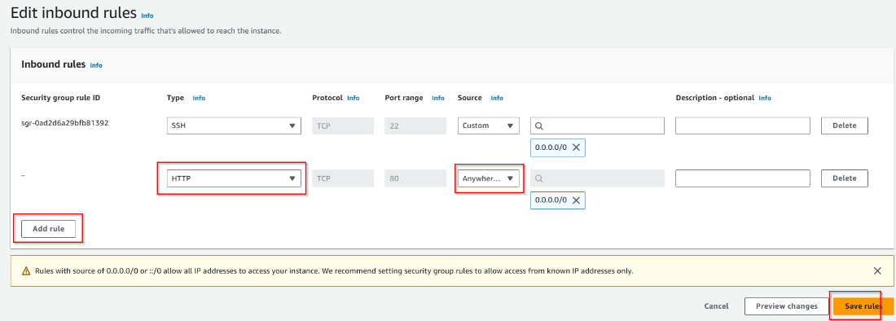

19.

In the Instances Menu, select “Instance State” and stop the instance.

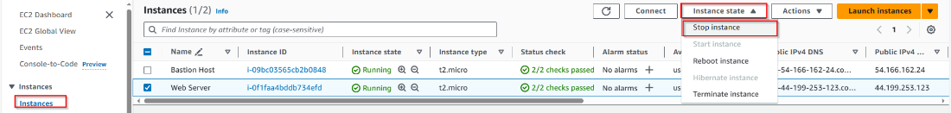

20.

Select “Actions”, “Instance Settings” and then “Change Instance Type”.

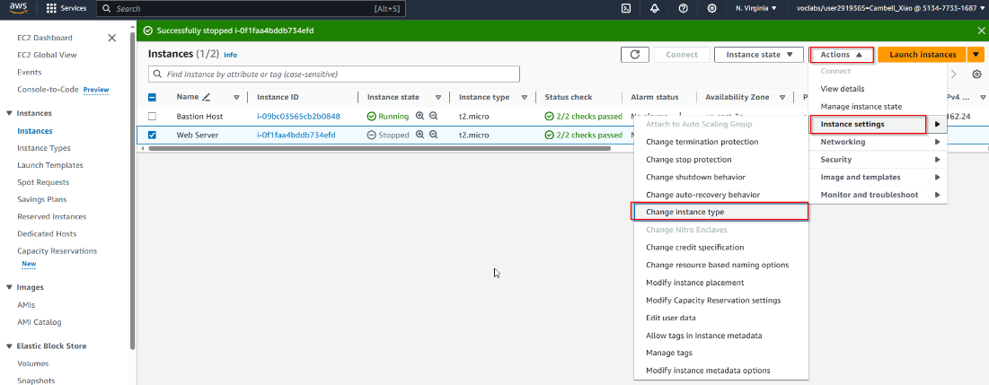

21.

Select “Instance Type” And change your instance type. Then Apply.

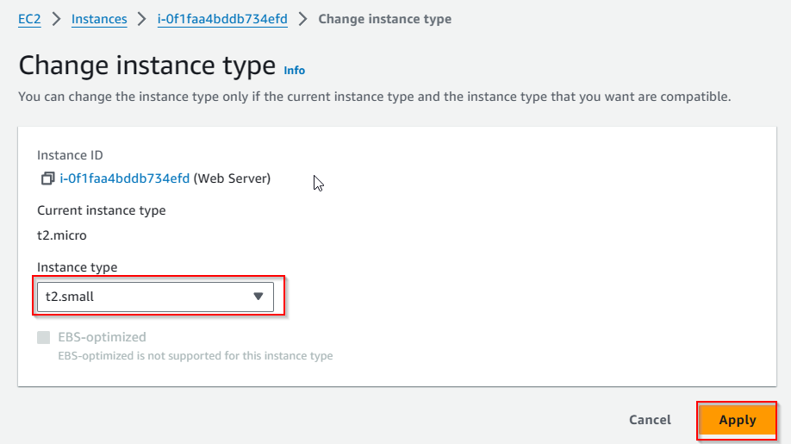

**Resize EBS Volume**

22.

Select “Storage” in your EC2 instance’s instance menu.

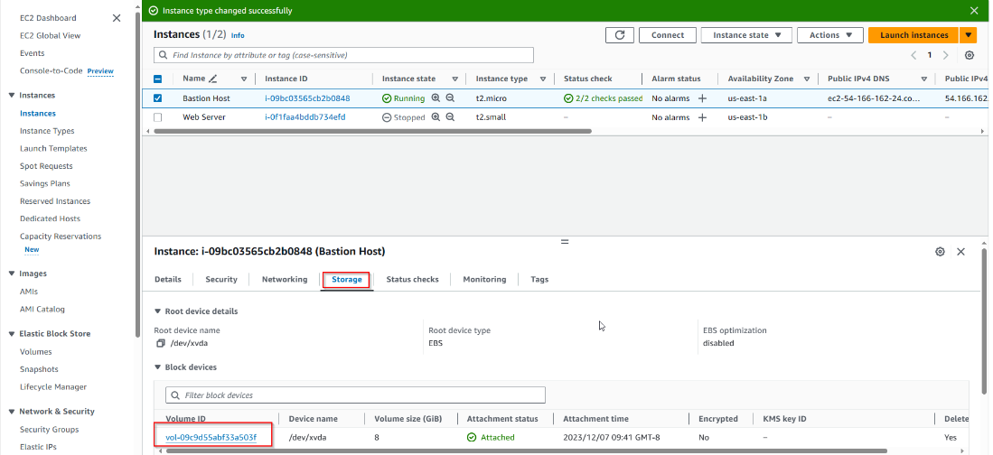

23.

Select your VPC and select “Actions”, “Modify Volume”.

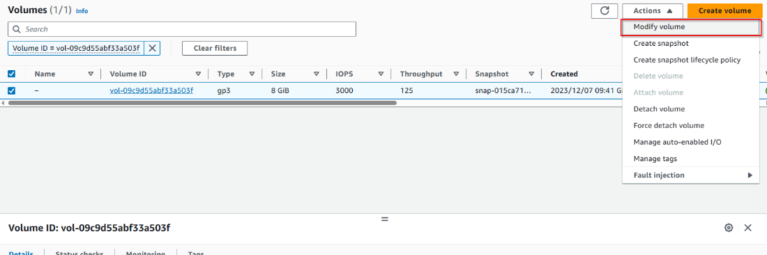

24.

Modify the volume to a desired storage size and then select “Modify”.

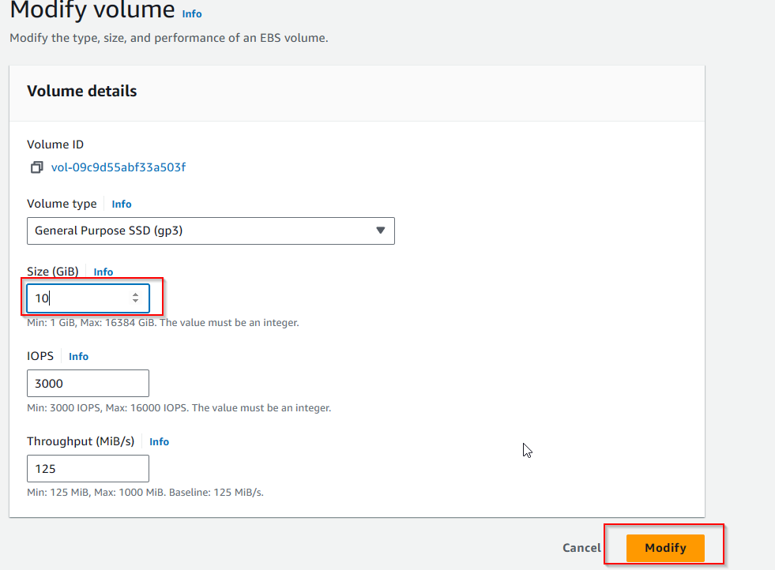

25.

Now that you have modified your instance, activate the instance again by selecting Instance State and Start Instance in the Instance manager menu.

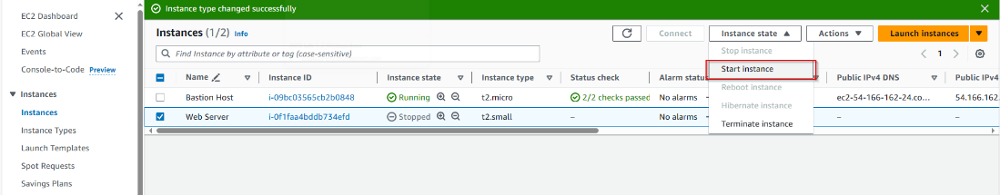

**Explore EC2 Limits**

27.

In the searchbat at the top left of your screen, search up and select “Service Quotas”

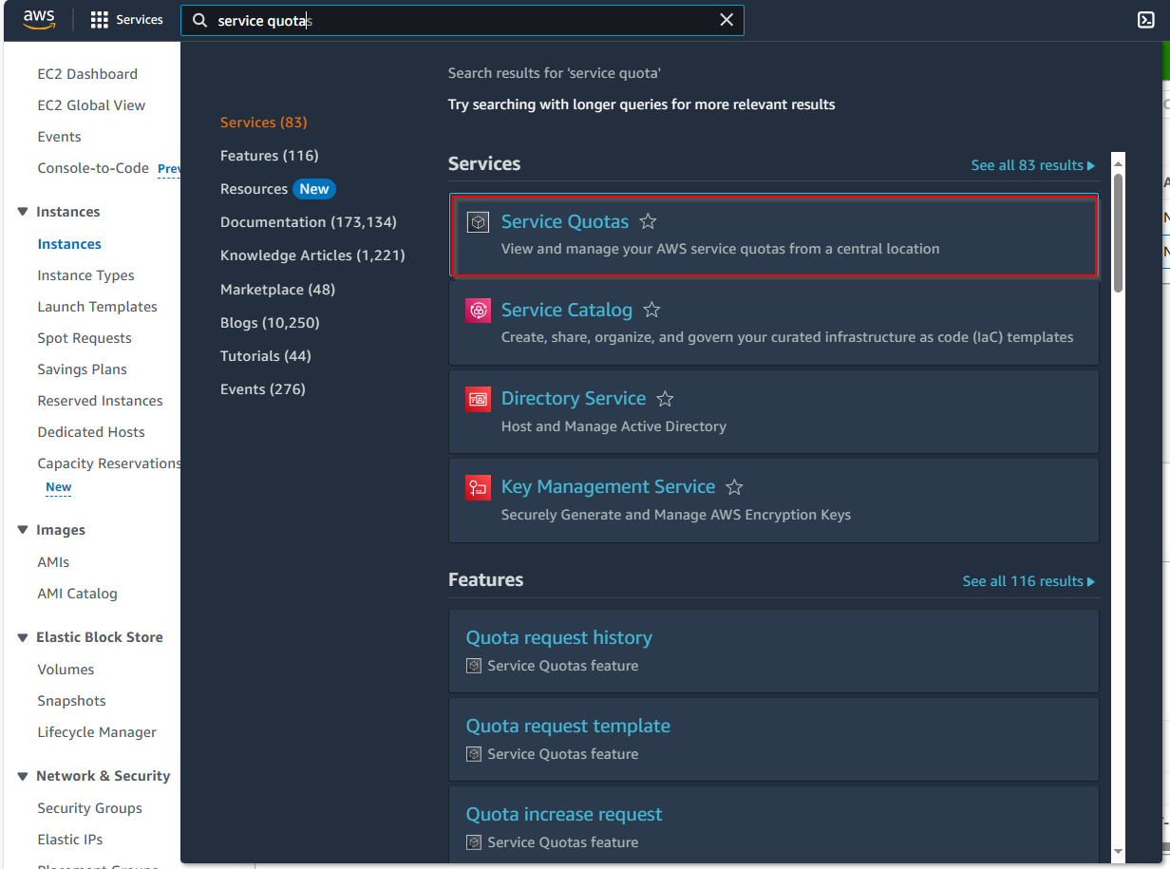

28.

In the AWS Services tab search and select “EC2”

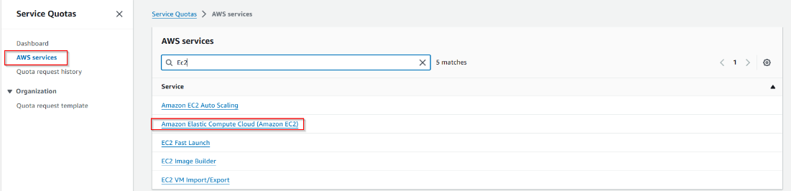

29.

Search up “running on-demand" and observe all the options on paying for on-demand storage. (pay as you go storage.

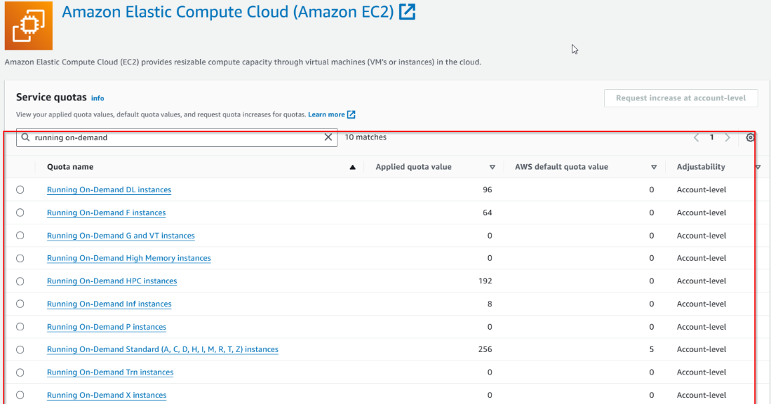

**Observing Termination Protection**

30.

Back in the EC2 Menu, select “Instance State” and “Terminate Instance”

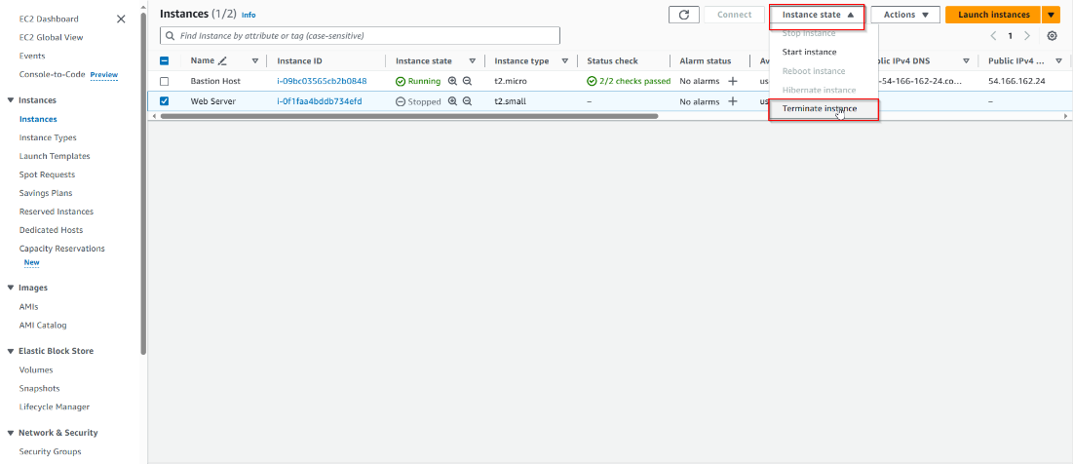

31.

Observer that the instance is unable to be terminated due to termination protection.

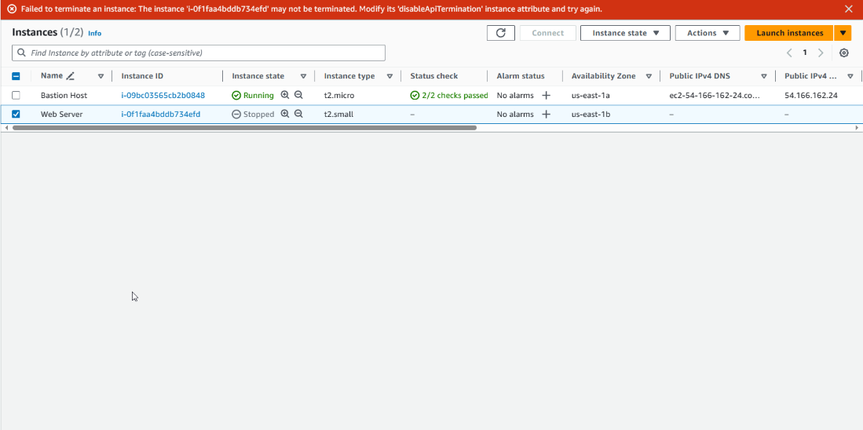

32.

Turn off termination protection by entering “Actions”, “Instance settings”, and “Change termination protection”

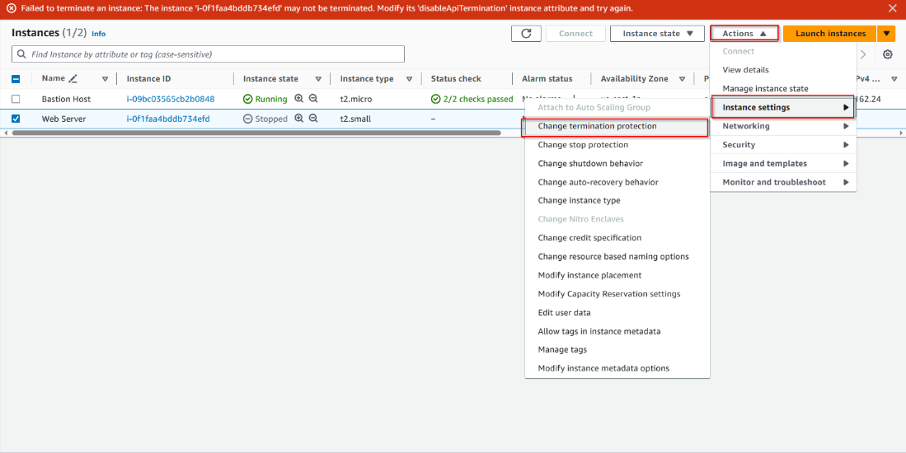

33.

Turn off Termination Protection and then

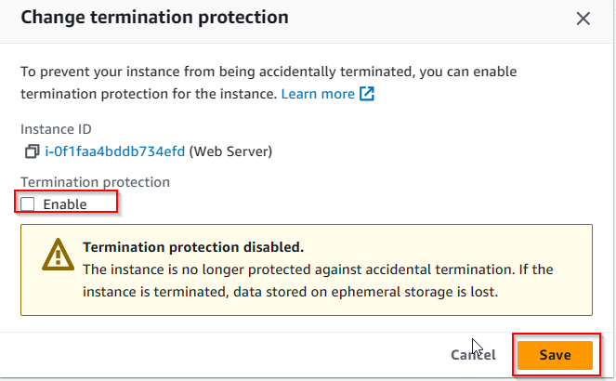

34.

Now you may terminate your instance.

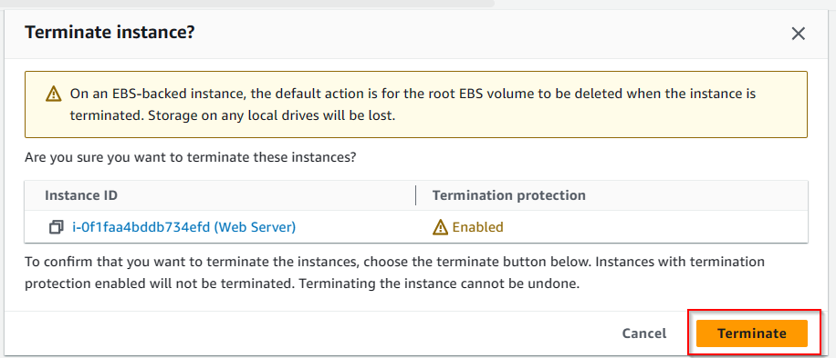

35.

Observe that the interface state is now Terminated

